**UNIVERSITY NAME: GLA UNIVERSITY, MATHURA**

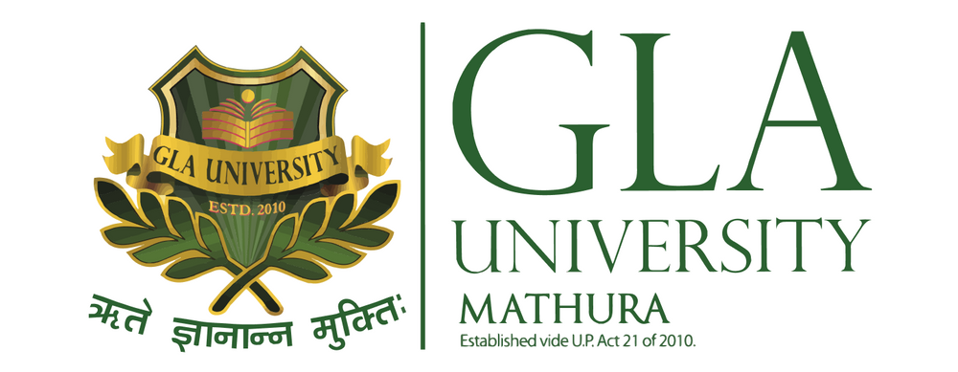



**TOPIC: MINI PROJECT SYNOPSIS ON Property Rental System focusing on college students**

**Submitted to:**

Faculty Name: Mr. Shiv Kumar Verma

Synopsis format by Akash

**DECLARATION**

We, the undersigned, hereby declare that the work presented in this mini-project titled **"Property Rental System"** is the result of our own research and efforts. We confirm that this project has not been submitted for any other course or examination, and all the information and ideas presented are original or appropriately referenced.

We take full responsibility for the content of this project and confirm that it will be completed by us in accordance with the guidelines and under the supervision of our faculty.

| **Team Members** | **Roll Number** |
| --- | --- |
| Aditya Sharma | 2215000117 |
| Devansh Agrawal | 2215000574 |
| Anushka Mishra | 2215000328 |
| Rudrika Raghav | 2215001504 |
| Vaishnavi Sharma | 2215001913 |

**INDEX**

**Index is a reference for synopsis only**

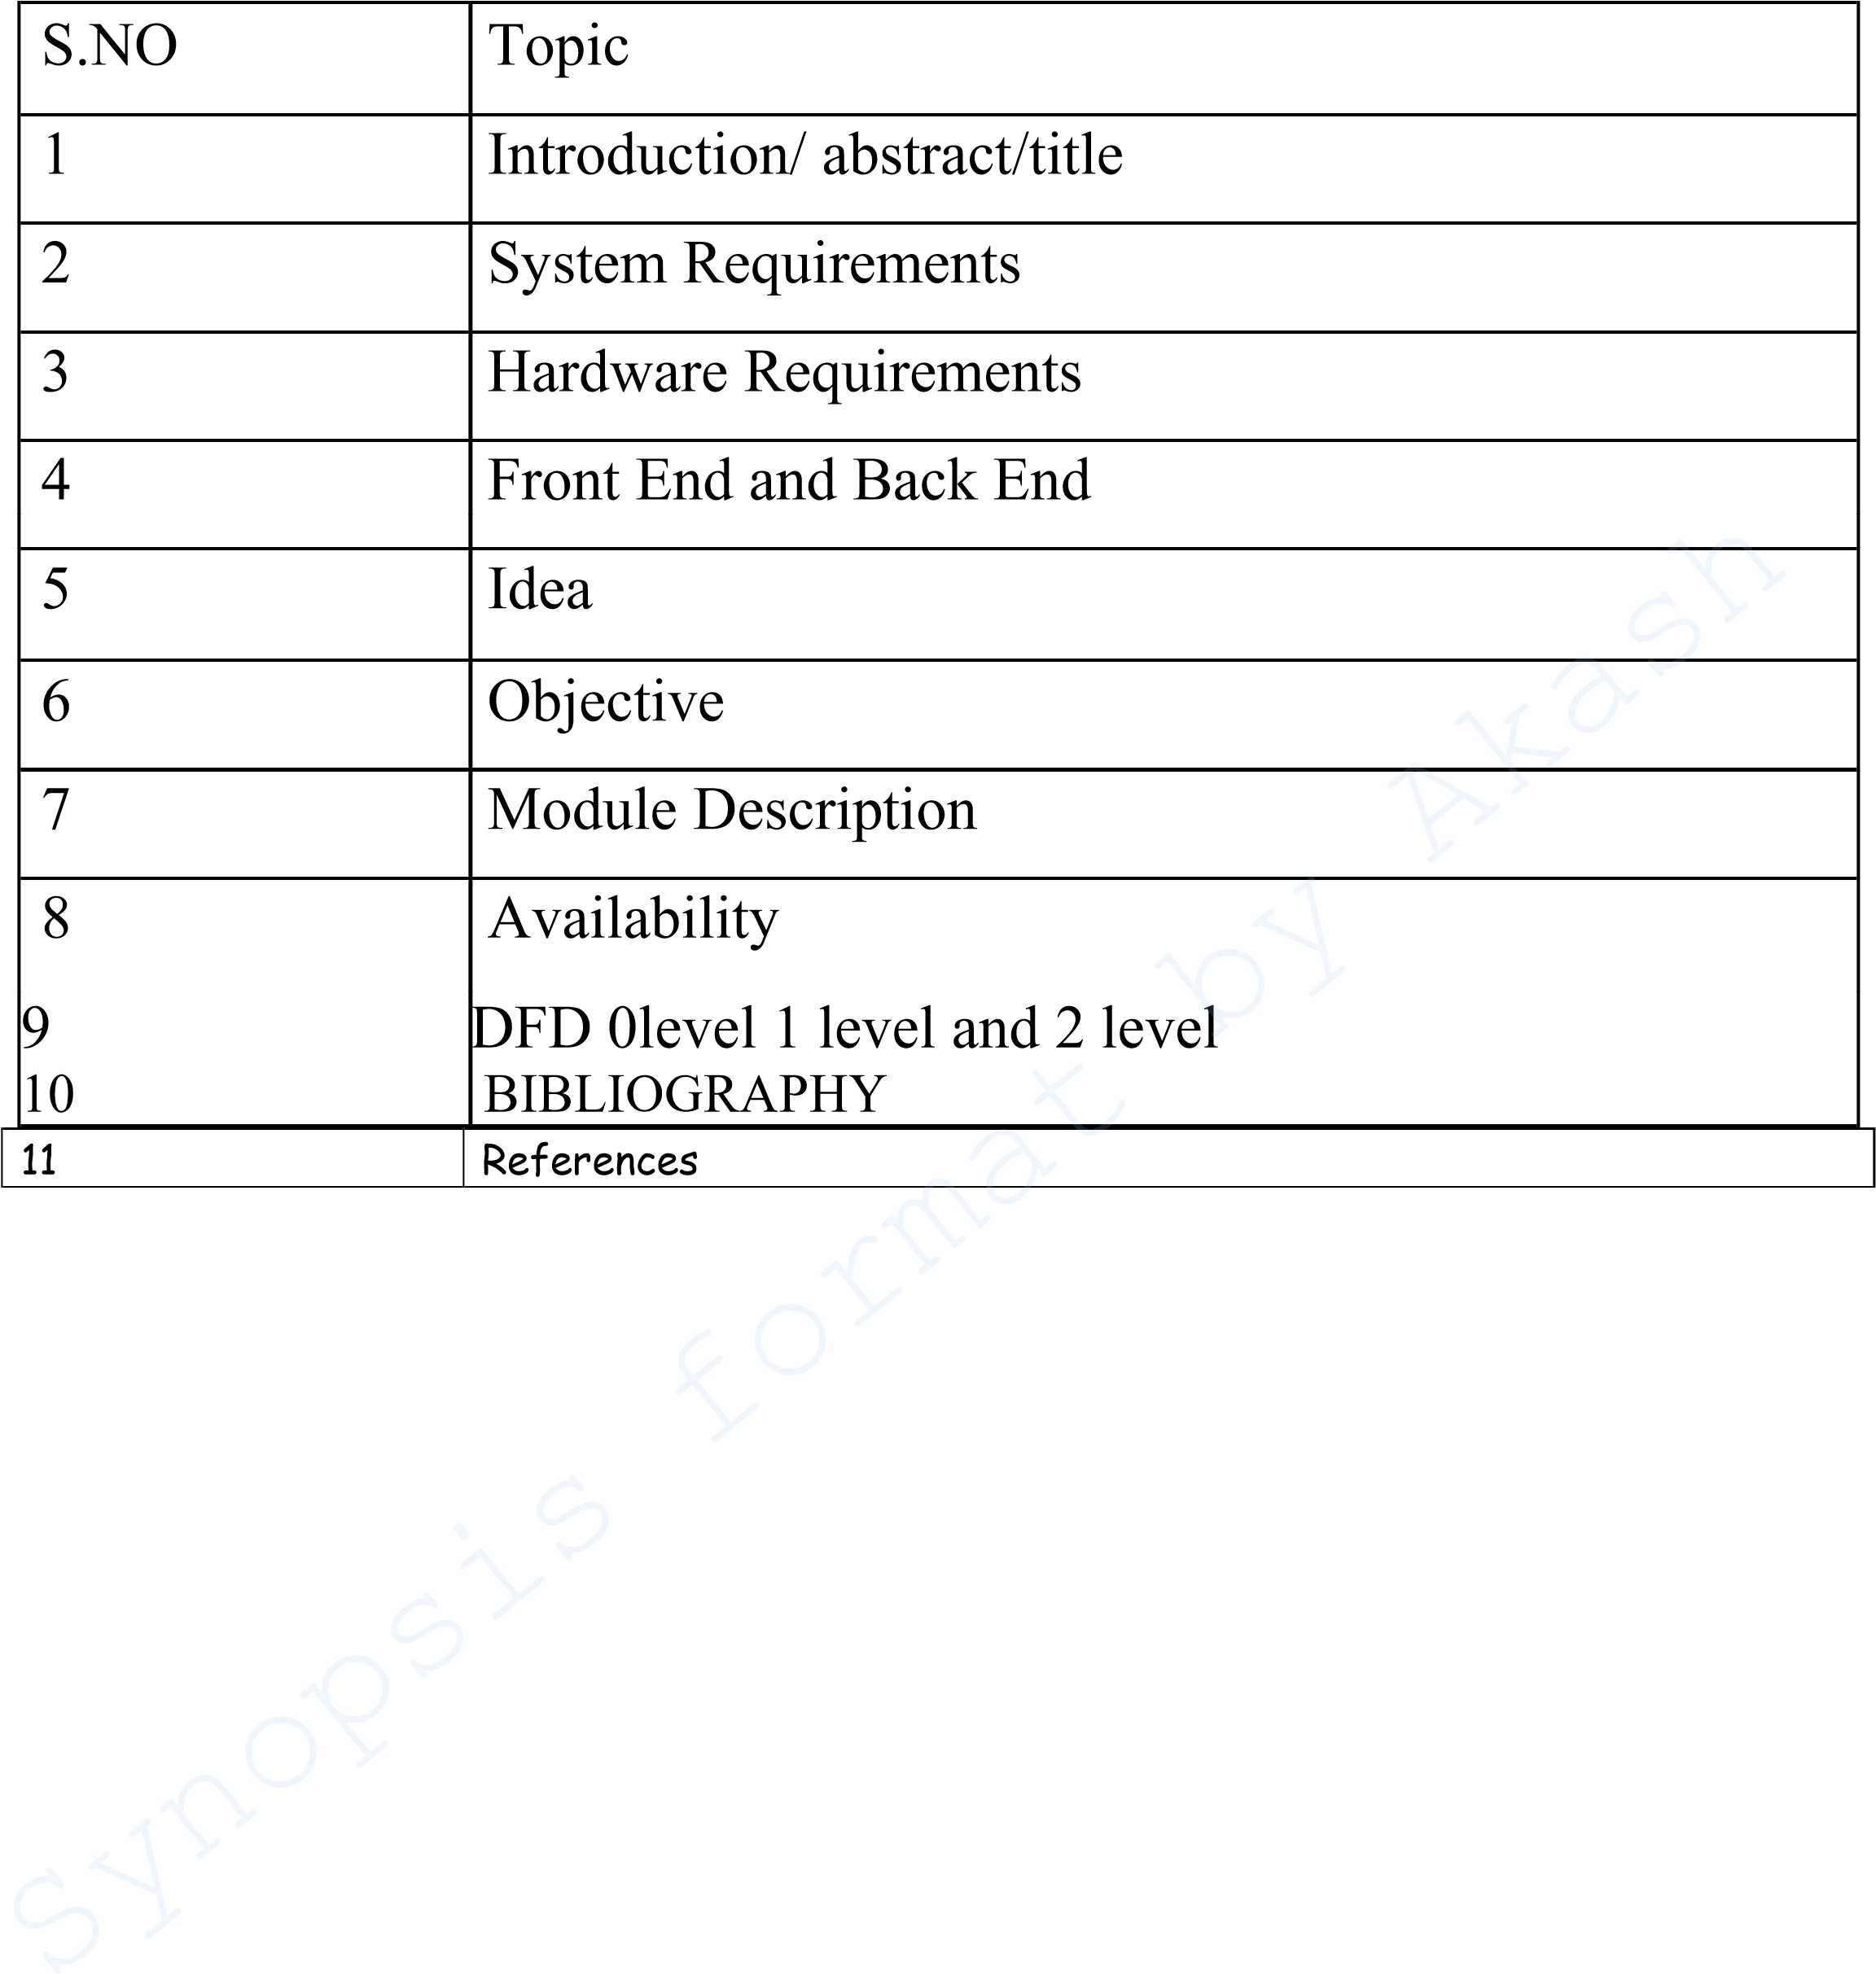

# INTRODUCTION: -

The **Property Rental System** is designed to cater specifically to students living outside their college in Mathura, unable to secure hostel accommodations. The system facilitates easy access to rental properties, particularly **PG accommodations**, by allowing property owners to list their properties, and students can browse and book based on their requirements. Additionally, the system will provide **directions to nearby messes** associated with each property, ensuring convenience for students in finding food options close to their residence.

**About the project**

The **Property Rental System** is a comprehensive web application designed to address the housing needs of students residing in Mathura who are unable to secure on-campus hostel accommodations. This platform simplifies the process of finding rental properties, with a particular focus on **PG accommodations**, by allowing property owners to list available properties, and enabling students to browse through these listings with ease.

The system not only offers a straightforward way to search for properties based on location, rent, and other preferences but also includes an additional feature where students can find **directions to nearby messes** and other food services associated with the chosen property. This feature ensures that students have access to affordable food options near their accommodation.

By offering a **seamless booking experience**, the platform bridges the gap between landlords and students, providing an all-in-one solution to help students find housing options that suit their needs. The project also aims to automate property listings, improve the search functionality, and enable efficient communication between landlords and students.

This system is designed to be highly **user-friendly**, **accessible**, and focused on the student community, ensuring that their unique housing and daily living needs are met.

# Primary Reason to Choose This Project

As a student, I personally experienced significant challenges when trying to find suitable accommodation outside the college during my immersion classes. Like many students who couldn't secure a spot in the hostel, I found it difficult to locate affordable and convenient rental options. Not only was it hard to find properties that fit my budget and requirements, but accessing essential services like nearby messes was also a challenge.

This project, Property Rental System, directly addresses these issues by creating a platform tailored specifically to students like myself, making it easier to find PG accommodations or rental properties and access necessary facilities such as food services in proximity to their residence. By choosing this project, we aim to solve a problem that affects many students, ensuring they have a hassle-free and efficient way to manage their housing needs while focusing on their studies.

**The Main Objective of the project**

The main objective of the Property Rental System is to develop a web-based platform that simplifies the process of finding rental accommodations, particularly for students residng in Mathura who are unable to secure hostel accommodations. The platform is designed to:

* Provide an easy-to-use interface for students to search for PG accommodations and other rental properties based on their preferences such as budget, location, and amenities.
* Offer directions to nearby messes and food services associated with each property, ensuring that students can access essential services in close proximity to their chosen accommodation.
* Enable property owners to efficiently list and manage their properties, while allowing students to directly interact with landlords and make bookings seamlessly through the platform.
* Facilitate better communication between tenants and landlords, streamlining the rental process and providing students with a one-stop solution for their housing needs.

This project aims to bridge the gap between students and property owners, creating a student-friendly environment where finding a place to stay and accessing necessary facilities becomes an efficient and hassle-free process.

# Scope Of the Project

The **Property Rental System** has a broad scope, catering to both students and property owners. It is designed to address the unique housing needs of students while also providing property owners with a streamlined platform to manage their listings. The scope of this project includes:

1. **Student Accommodation Search**:  
   The platform enables students to search for **PG accommodations** and rental properties based on criteria such as rent, location, amenities, and proximity to their college. The system focuses primarily on students who cannot secure hostel accommodations and need reliable, affordable housing solutions.
2. **Nearby Mess Directory**:  
   In addition to providing accommodation listings, the system offers directions to **nearby messes** or food services linked to each property. This ensures students can find convenient dining options without having to search separately.
3. **Property Owner Management**:  
   Property owners can easily list their properties, update information, and manage inquiries from potential tenants. The platform allows for efficient property management, ensuring that owners can quickly respond to student needs and inquiries.
4. **User-Friendly Interface**:  
   The system is designed to be intuitive and easy to use, ensuring that both students and property owners can navigate it without any technical difficulties.
5. **Data Integration and Mapping Services**:  
   The system integrates mapping services to provide **accurate directions** to nearby food services and other amenities, ensuring a complete, location-based solution for users.

The project has the potential to significantly ease the rental search process for students, making it a highly relevant and impactful solution for the student community.

**Working methodology of the project**

**1. Requirement Analysis**

* Identify user needs: students looking for rental properties and nearby messes.
* Gather requirements through surveys or discussions with potential users.

**2. System Design**

* Create wireframes for user interfaces: separate portals for PG, Property listings, and Mess directions.
* Design database schema to handle user data, property details, and tags for easy searching.

**3. Technology Stack**

* Frontend: HTML, CSS, JavaScript (or frameworks like React).
* Backend: Nodejs, Express
* Database: MongoDB.

**4. Development**

* Portal Development:
  + PG Portal: Allow users to register, log in, and post their properties.
  + Property Portal: Enable users to browse properties, filter by tags, and contact landlords.
  + Messes Portal: Provide information on nearby messes, including reviews and directions.
* Implement user authentication and role-based access for secure access.

**5. Integration**

* Connect frontend with backend services using REST APIs.
* Ensure smooth data flow between the database and user interfaces**.**

**Details About the Hardware and the Software**

# System Requirements: -

**Supported Operating system:**

* **Windows**: Windows 10 or later.
* **Linux**: Any modern distribution (Ubuntu, Fedora, etc.) with necessary libraries installed.

**Software Required:**

* 1. **Frontend Development-** 
     1. **React**
     2. Tailwind CSS
  2. **Backend Development-**
     1. Node.js
     2. Express.js
     3. JWT (JSON Web Tokens)
  3. **Database**
     1. MongoDB**,** Mongoose
  4. **State Management**
     1. **Redux Toolkit** or **Context API**
  5. **Version Control and Collaboration**
     1. **Git** and **GitHub**
     2. Postman
  6. **Authentication**
     1. OAuth or JWT for secure user sign-in and registration.

**DATA FLOW DIAGRAM**

0 LeveL DFD

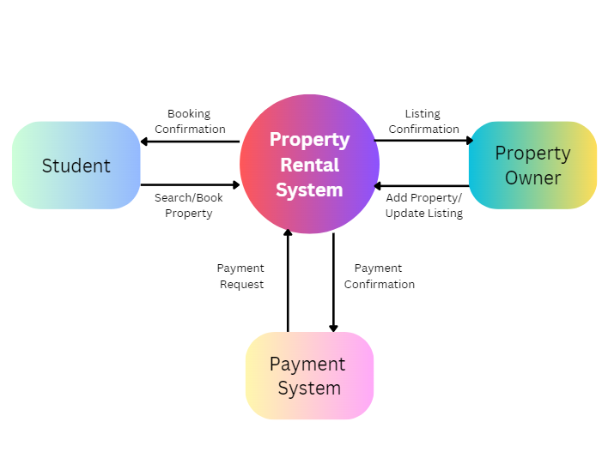

1 Level DFD:

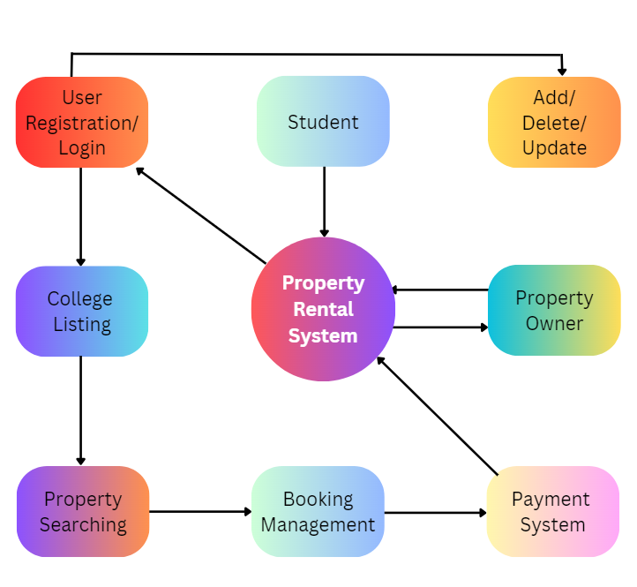

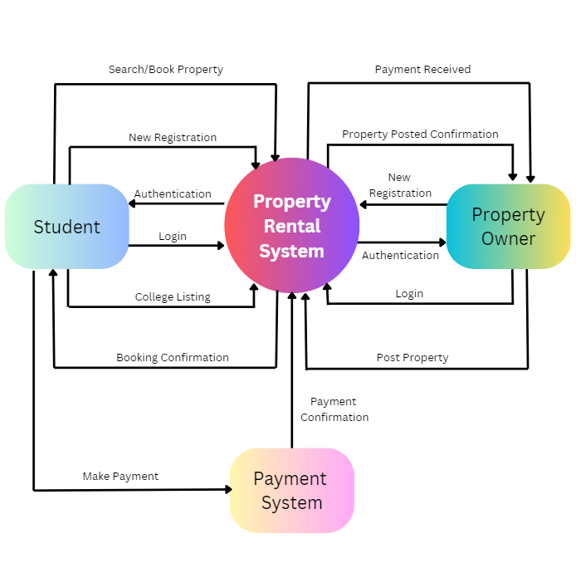

2 Level DFD:

**WEBSITE OVERVIEW**

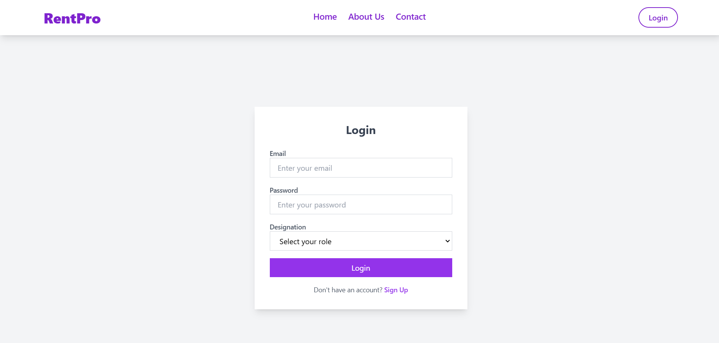

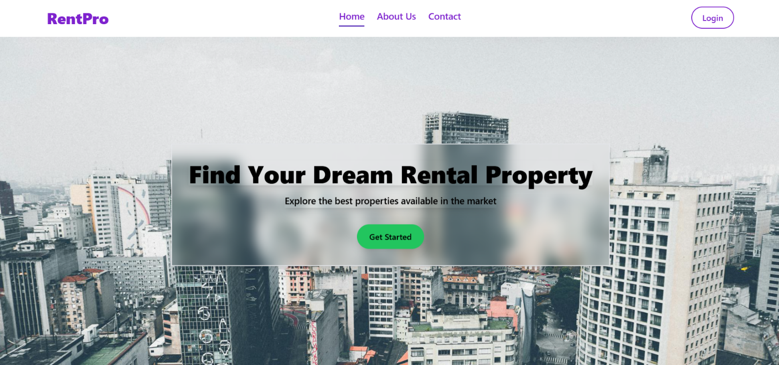

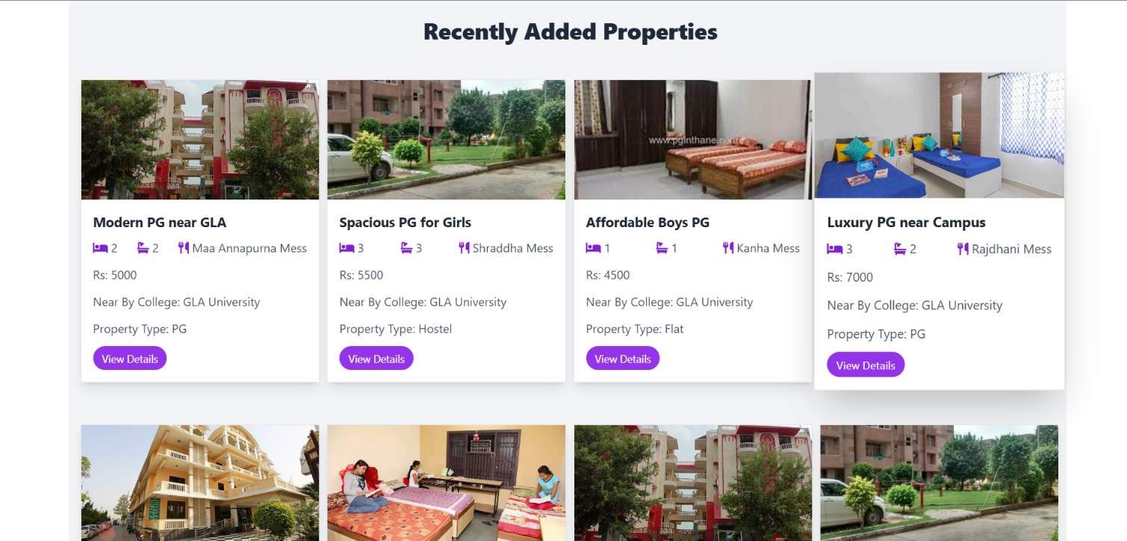

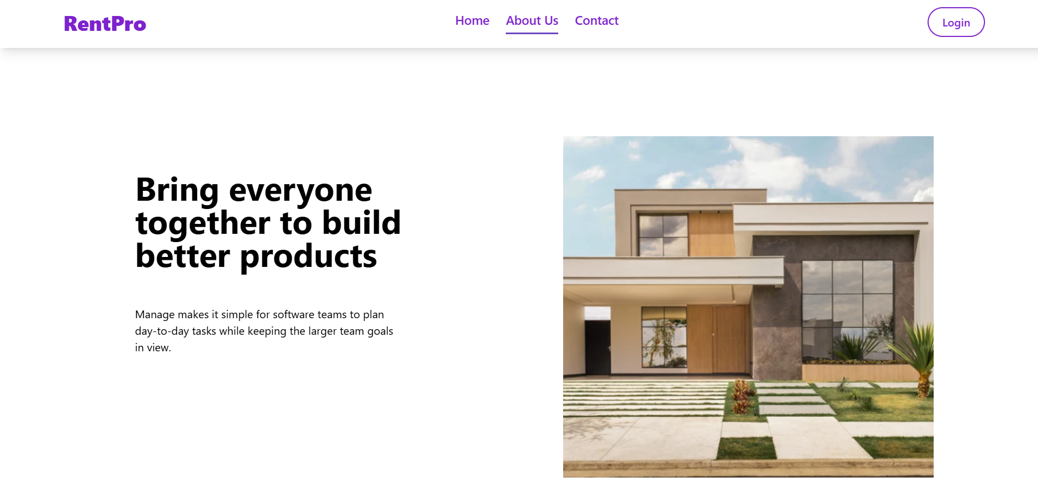

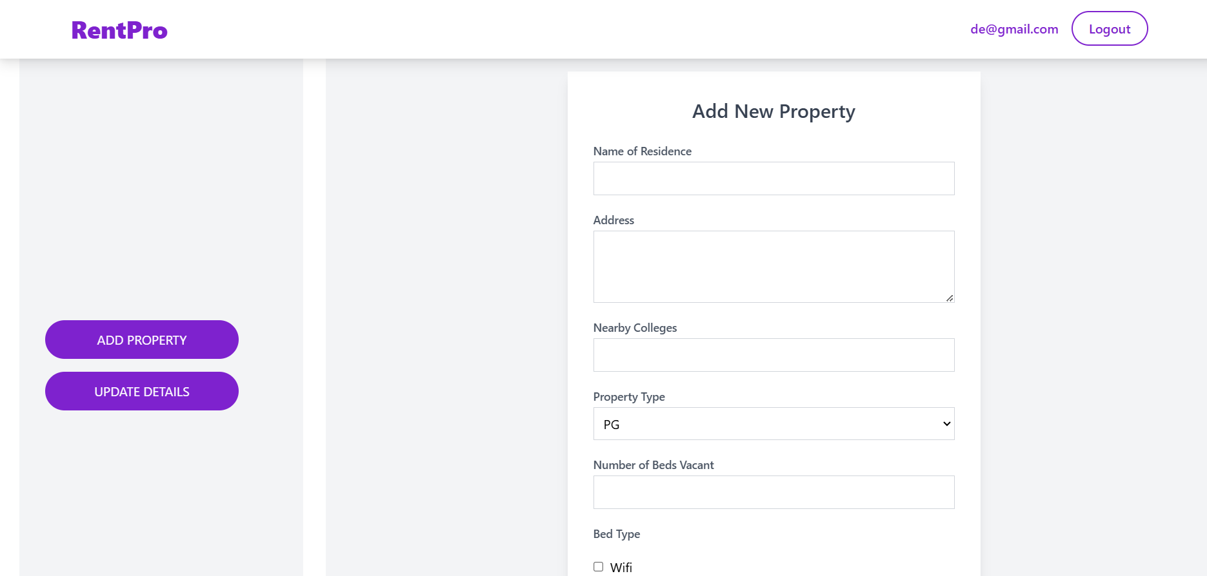

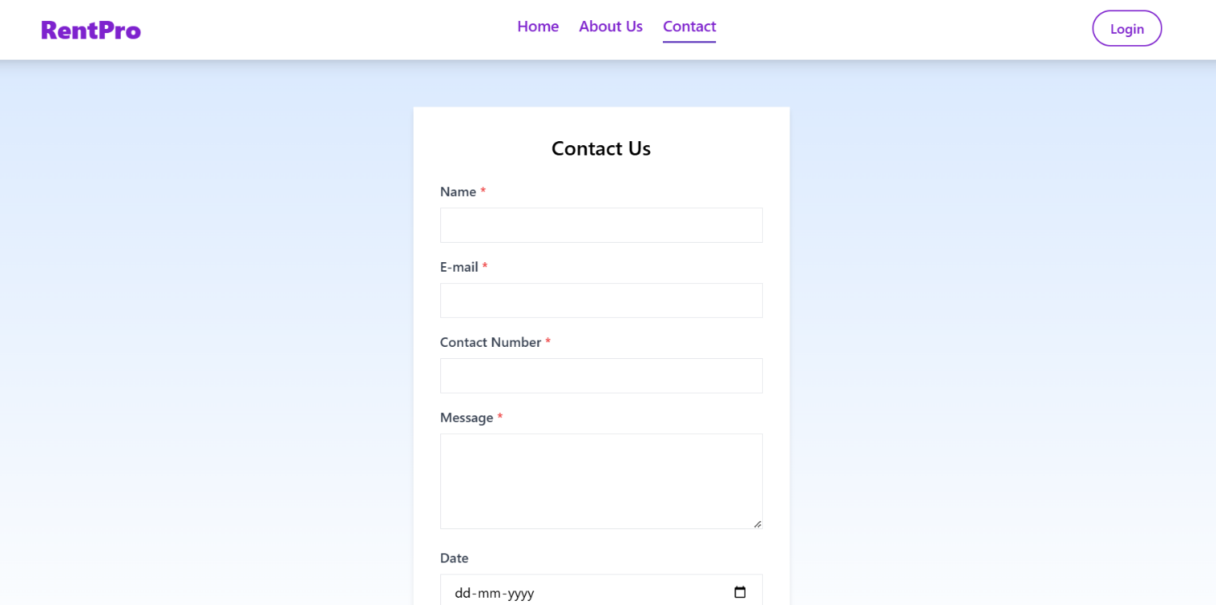

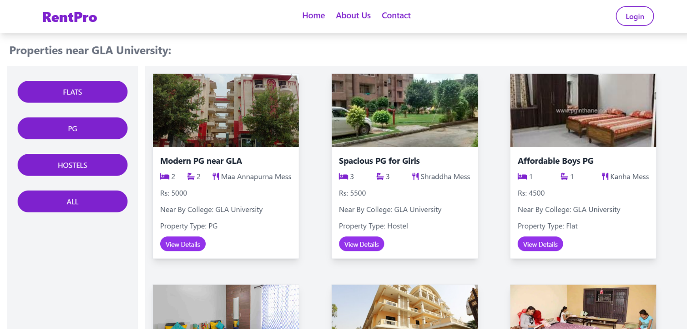

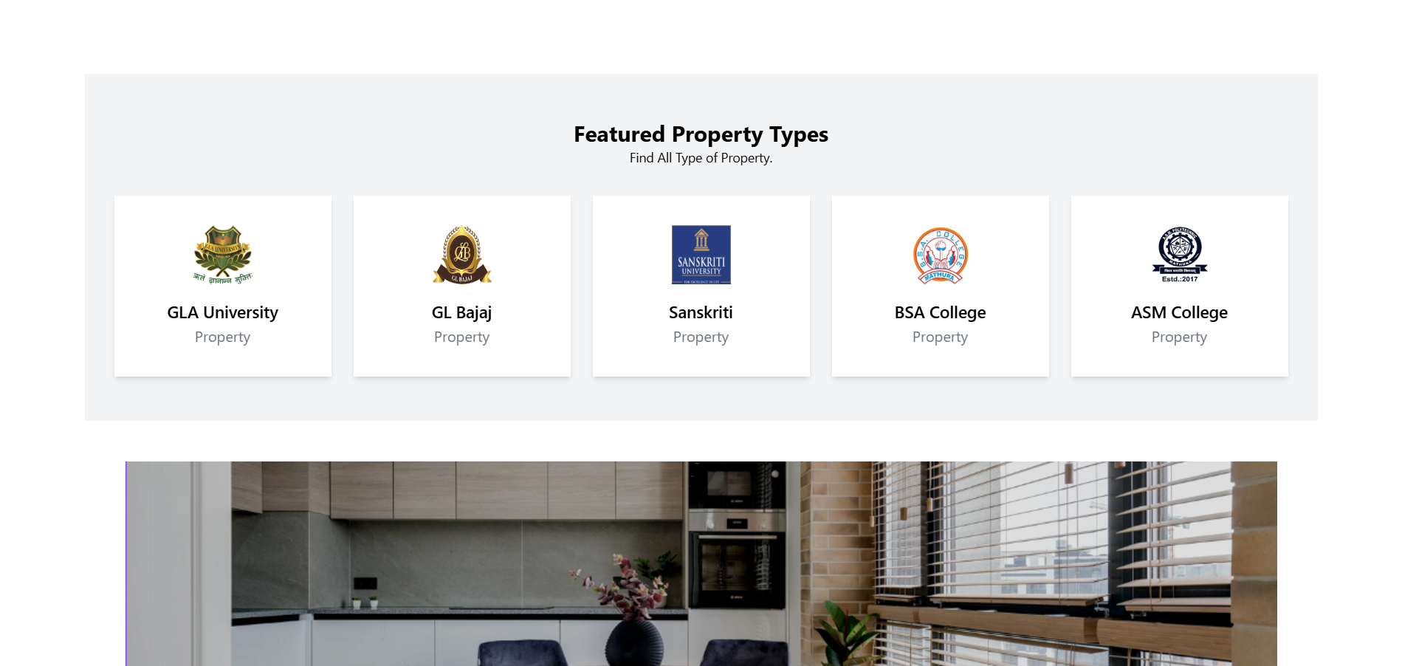

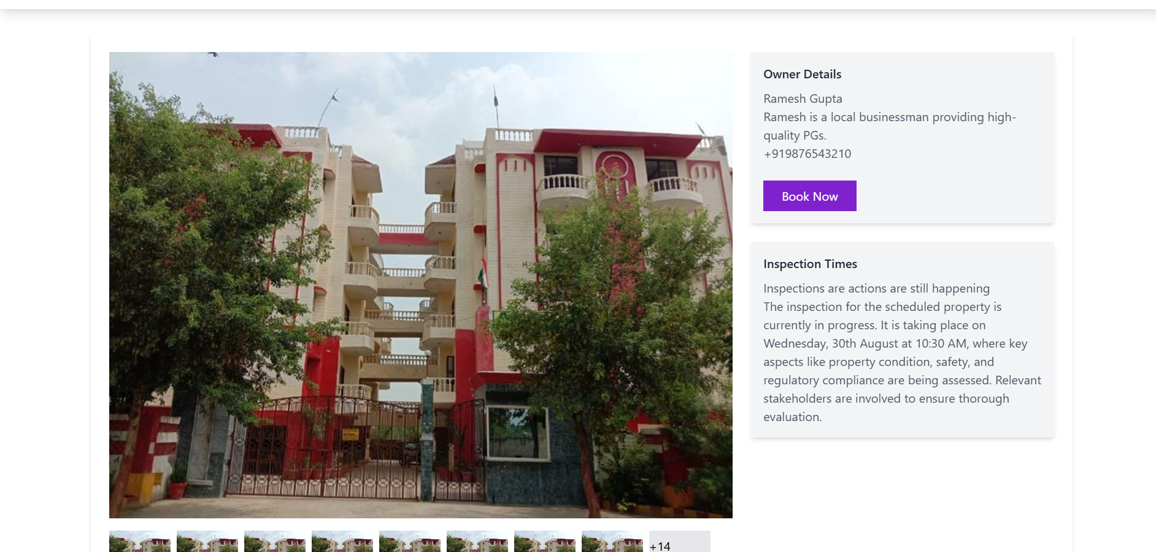

**DATABASE MANAGEMENT**

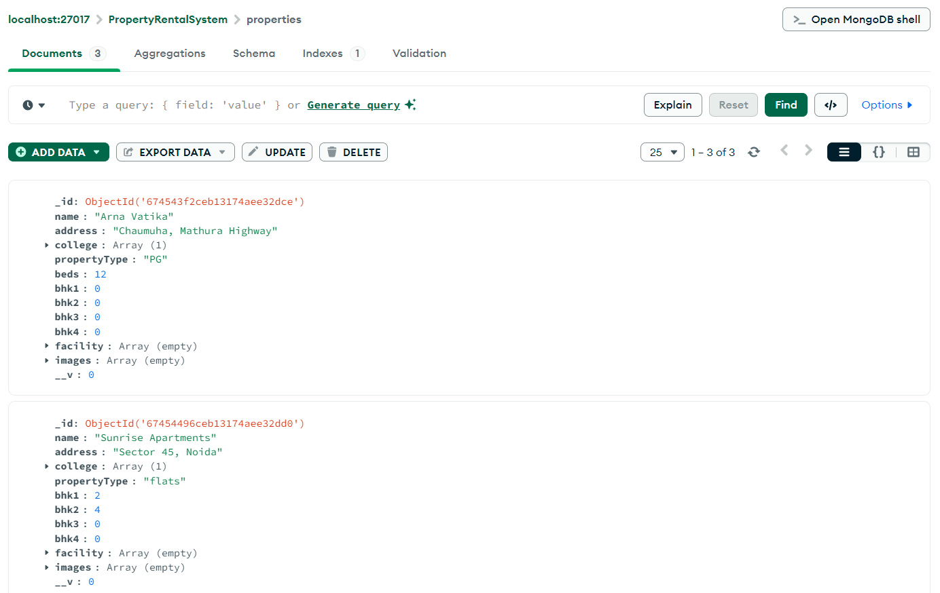

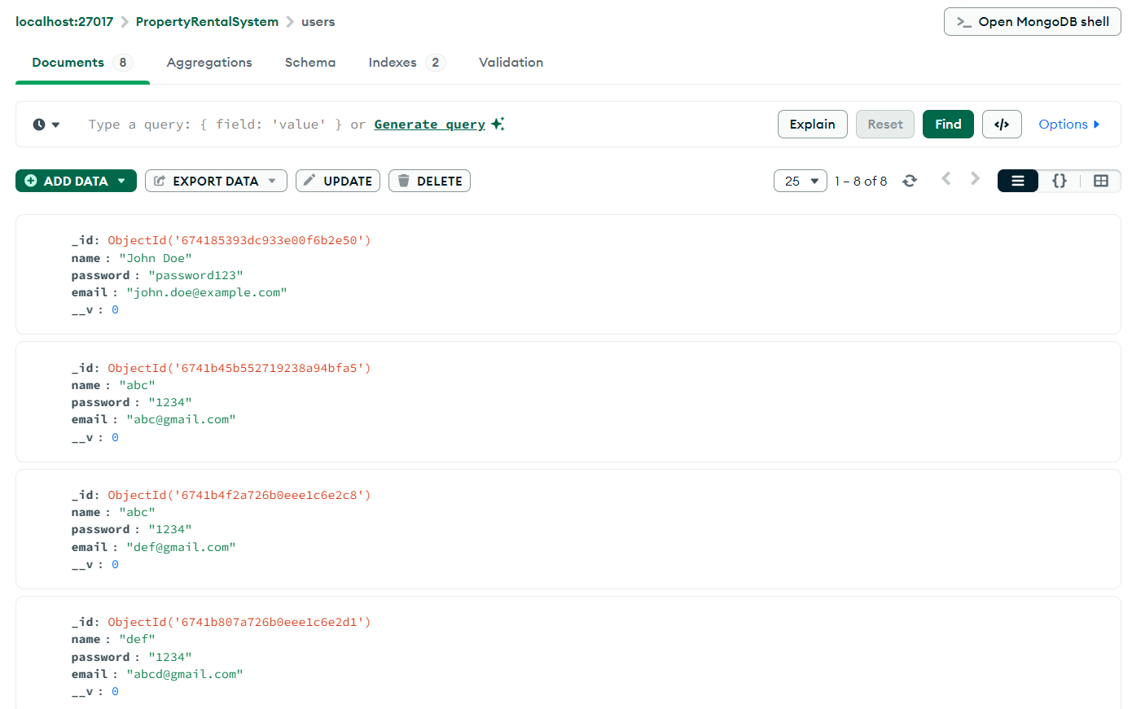

**BACKEND CODE**

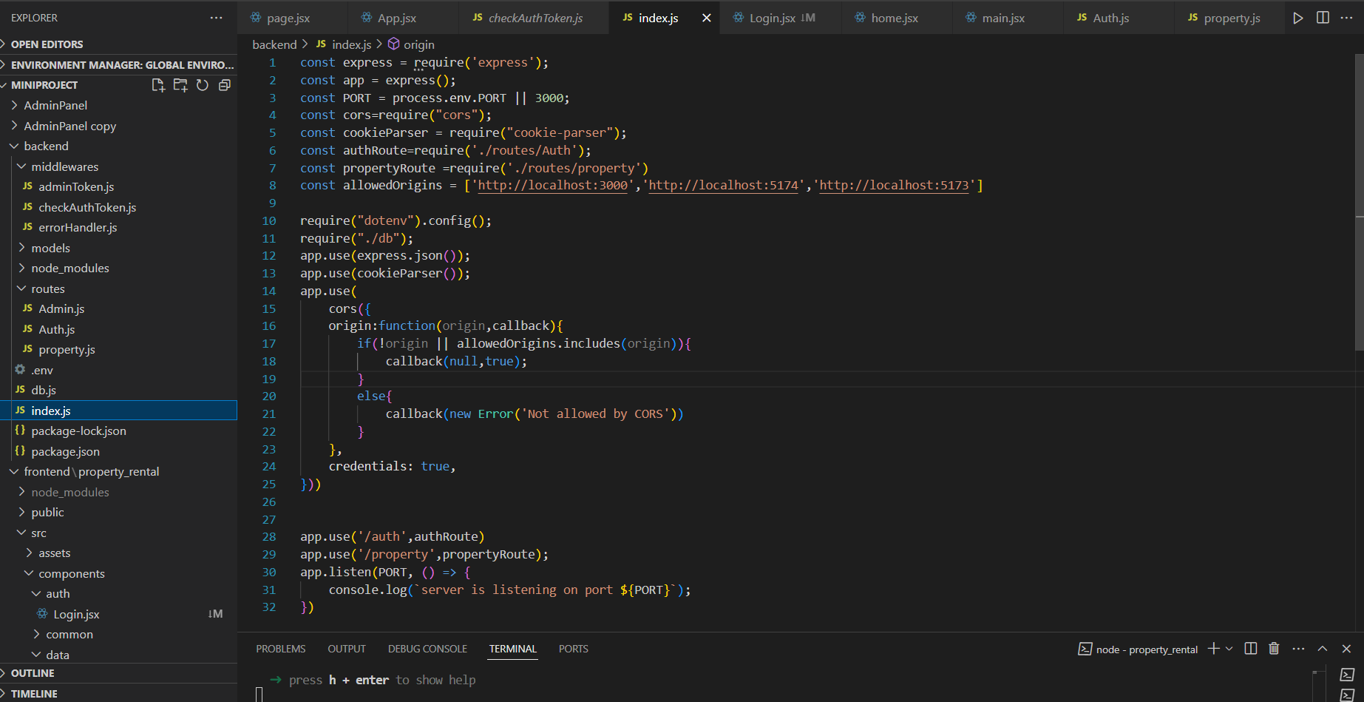

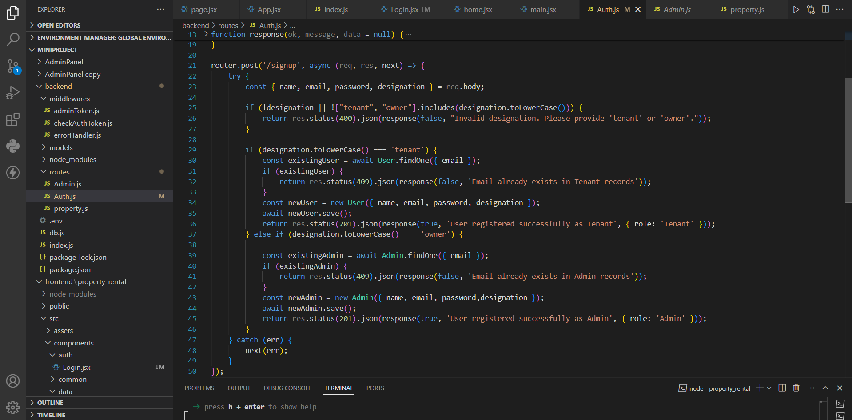

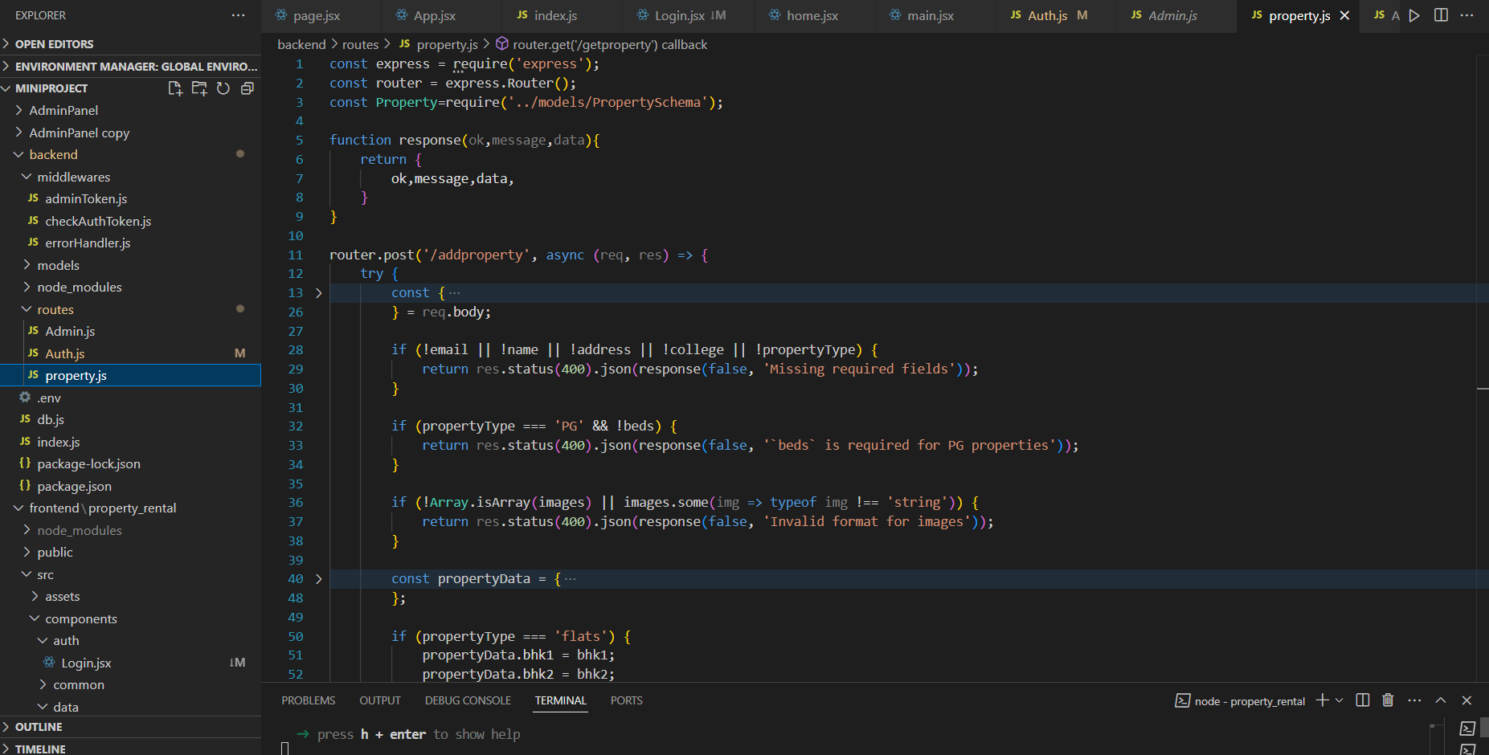

**GITHUB LINK**

[**https://github.com/rudrika2425/miniProject/tree/master**](%20https://github.com/rudrika2425/miniProject/tree/master)

**Conclusion**

In conclusion, the **Property Rental System** designed for college students residing in Mathura provides a seamless and efficient solution for finding suitable accommodations, including PGs, hostels, and flats. With the system’s user-friendly interface and advanced filtering options, students can easily explore rental properties that match their preferences in terms of location, budget, and amenities. The platform not only streamlines the process of searching for accommodation but also enhances convenience by integrating features like detailed property descriptions, image galleries, and user reviews. By offering a dedicated platform for Mathura’s student population, this system bridges the gap between property owners and students, ensuring transparency and accessibility. The inclusion of real-time availability, online booking, and payment options further simplifies the process, allowing students to focus on their studies while ensuring they find the perfect place to stay. Ultimately, this system provides a valuable resource that supports the housing needs of students and fosters a connected rental community in the city.